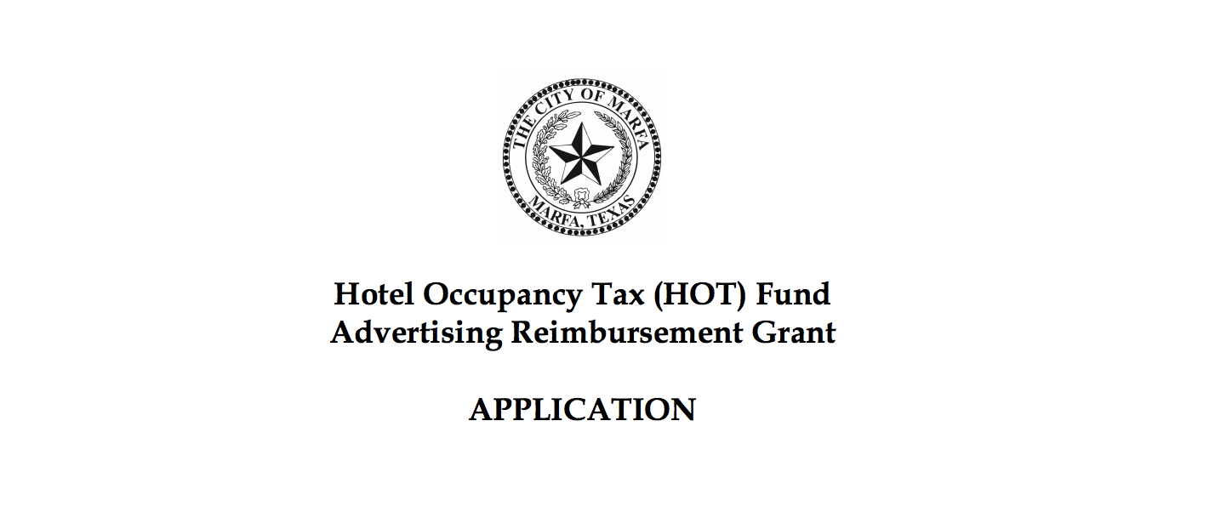

Section A, Organization Information

Organization Name:

Physical Address:

Mailing Address:

Contact Name:

Contact Phone Number:

Web Site Address for Event or Sponsoring Entity:

Non-Profit or For-Profit status: Tax ID #:

Entity’s Creation Date:

Purpose of your organization:

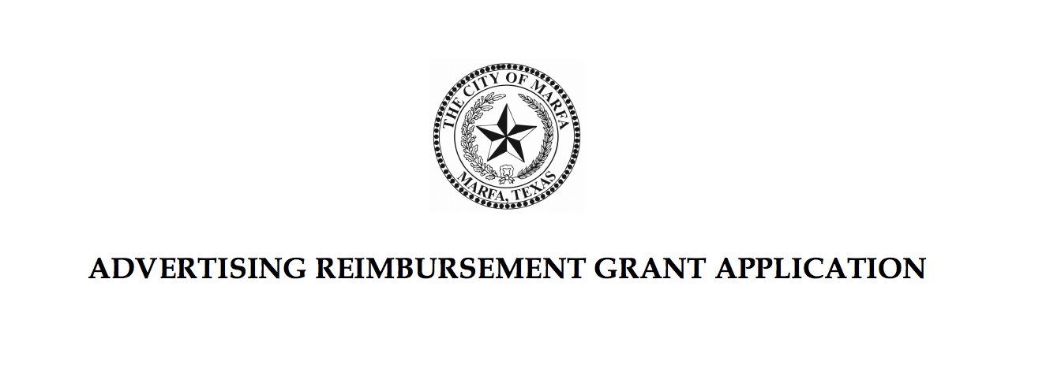
Section B, Project Information

Name of Event or Project:

Date and Location of Event or Project:

Amount Requested: $

Project Eligibility

- Will the proposed activity, if funded, directly enhance and promote tourism in Marfa, Texas? ___Yes ____No

2. If funded, will the grant clearly pay for advertising, solicitations, and promotional programs planned to attract tourists and convention delegates or registrants to the municipality or its
vicinity?

____Yes ____No

Project Narrative

Please use the following page to tell us about your event and include the following information:

1. What is the primary purpose of the activity or project which you are advertising or promoting?

2. How will this activity directly enhance and promote tourism in Marfa?

3. How many years have you held this event?

One-Page Project Narrative

Tourism Outcomes

1. How many people do you expect to attend your event or activity?

2. How many people in attendance do you expect will come from outside of the tri-county area?

3. How many do you expect will rent rooms in Marfa?

4. How many nights do you expect they will they stay?

5. Will you reserve a room block at an area hotel and if so, for how many rooms and at which hotels?

6. How will you measure the impact of your event on area hotel activity (e.g.; room block usage information, survey of hoteliers, etc.)?

7. If your grant request is for promoting ongoing programming at a permanent facility (e.g. museum, visitor center):

a. What was your organization’s annual attendance last year?
b. What percentage of your visitors come from outside the tri-county area?

Budget

8. Will you charge admission? If so, what is the admission cost?

9. Do you anticipate a net profit from the event? If there is a net profit, what is the anticipated amount and how will it be used?

10. On the following page, please submit a budget for your project, including anticipated funding from HOT, other organizations, and other grants or donations.

One-Page Project Budget

Section C, Advertising and Promotion

Please give us details about your promotional efforts. List the newspapers, magazines, websites, etc. where your organization will advertise and the dollar amount committed to each.

Newspaper:

Magazine:

Radio:

Social Media:

Other Paid Advertising:

Number of Press Releases to Media with Dates:

Number of Direct Mailings to out-of-town recipients:

Other Promotions:

How many individuals will your proposed marketing reach who are located in another city or county?

Section D, Assurances

If a reimbursement grant is awarded, the applicant hereby assures the City of Marfa that:

1. The activities and services for financial assistance sought will be administered by the applying organization.

2. Any funds received through this application will be solely used for the event described.

3. Proper credit will be given to the City of Marfa, using its tourism logo on all advertising and promotion of the event.

4. The undersigned have been authorized by the applicant to submit this application.

President or Chairman /

Date:

Project Director /

Date:

Section E, Application Checklist

Please confirm you have fully completed and included the following:

- Section A, Organizational Information

- Section B, Project Information
  - Eligibility
  - Project Narrative
  - Outcomes
  - Budget

- Section C, Advertising and Promotion

- Section D, Assurances

Please submit your application electronically by 5:00 pm on deadline.
Late applications will be considered based on availability of funds.
Please submit via email to hotgrants@cityofmarfa.com

